2024 Annual Report
Ammara Talib
1/6/2025
Objectives: The aim of this study is to investigate how water use efficiency (WUE) and carbon use efficiency (CUE) vary within ecosystems. The specific objectives are to 1) assess whether variations in WUE and CUE across ecosystems reflect ecosystem variability, and 2) examine whether WUE and CUE in coastal ecosystems are indicative of salinity levels.
1.1 Major findings of the effect of salinity on WUE and CUE at sites in Florida
Measuring soil moisture and hydro-edaphic factors is a complex process. Since vegetation responds to soil water availability, tracking changes in water use efficiency (WUE) and carbon use efficiency (CUE) can be an effective way to monitor shifts in soil conditions and detect salinity changes in coastal ecosystems. In this study, first total WUE was calculated for five Florida sites (Fig. 1). Among these sites, only one is situated in a forest ecosystem (US-Skr), while the remaining sites are wetlands. During the growing season (April-August), annual salinity levels ranged from 9 to 34 ppt across these sites. The US-Tas site (Taylor Slough/Panhandle) is a wetland with the highest salinity but exhibited low WUE in both 2018 and 2019. However, the relationship between salinity and WUE is not linear. For example, the US-EVM site (Everglades Saltwater Intrusion Marsh) had lower salinity but also lower WUE. This may reflect biome differences, or it could indicate that extremely low or high salinity levels result in lower WUE compared to moderate salinity levels in some biomes.
Fig. 2 illustrates total annual CUE during the growing season, revealing an inverse relationship between WUE and CUE. For instance, the maximum WUE of 4 g C per kg H₂O was observed at the US-KS4 site (Kennedy Space Center Spartina Marsh) in 2021, which had a moderate salinity of approximately 23 ppt. However, this site also recorded the lowest CUE (Fig. 2).
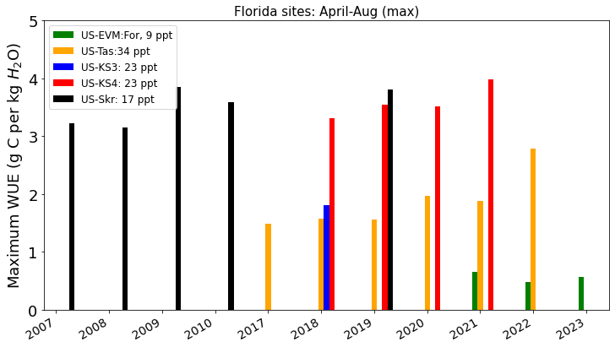
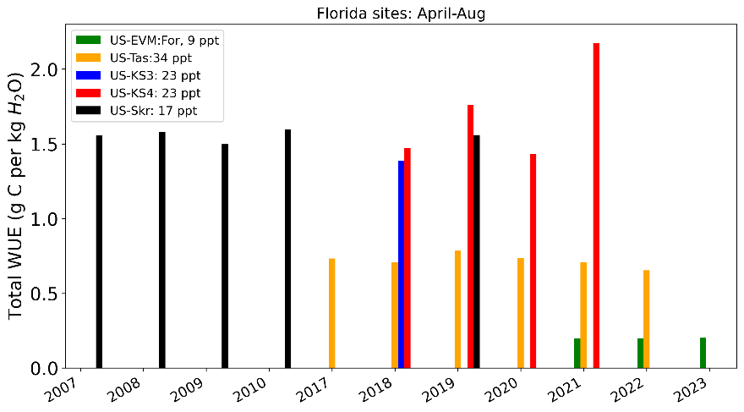

Fig.1. The total and maximum WUE for five coastal Florida sites are displayed, calculated specifically for the growing season. Salinity values are provided in the legend for context.
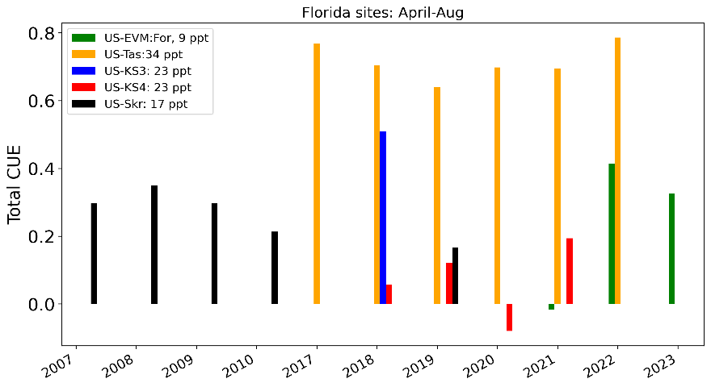
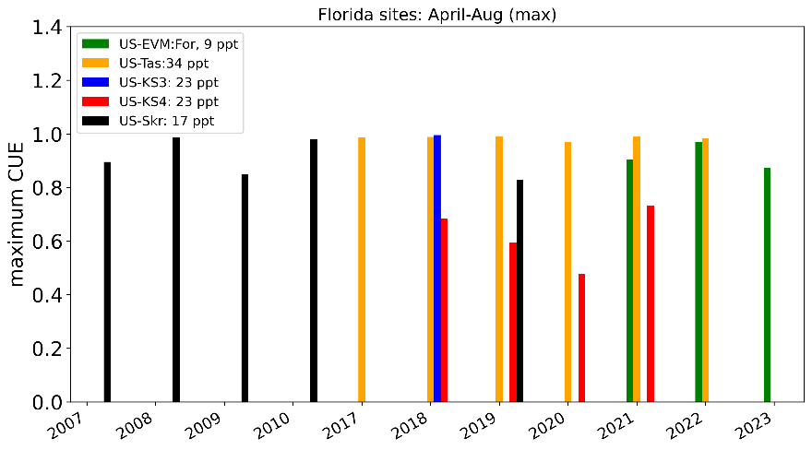

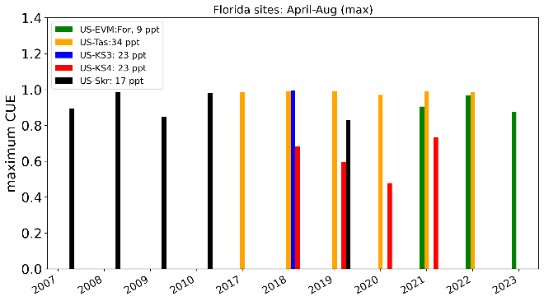
Fig. 2. The annual total CUE for five coastal Florida sites is calculated, with salinity values included for reference. CUE was determined exclusively for the growing season, with both total and maximum CUE values presented.

1.2 Effect of salinity on WUE in different ecosystems
To examine the impact of salinity on WUE, 12 study sites were categorized into three salinity levels (Fig. 3): high salinity (>30 ppt), medium salinity (10-30 ppt), and low salinity (<9 ppt). Data from 2017 to 2020 revealed that sites with higher salinity generally exhibited lower WUE, while sites with lower salinity showed higher WUE. An exception was the US-EKP site in California, which may reflect plant adaptations to high salinity at certain locations.
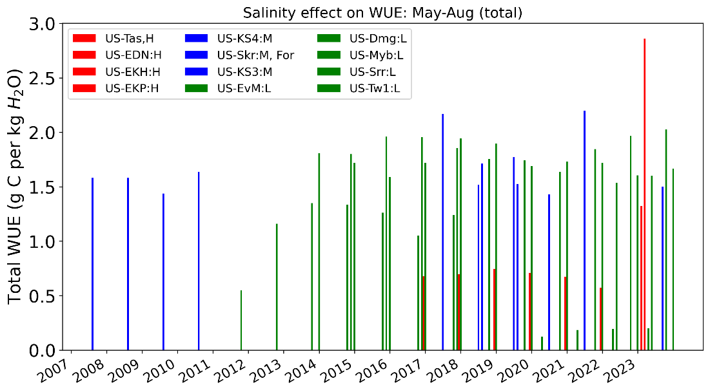

Fig. 3: The effect of salinity on WUE is depicted by categorizing the study sites into three groups: high (H), medium (M), and low (L) salinity. Red bars represent sites with high salinity, blue bars indicate sites with medium salinity, and green bars correspond to sites with low salinity.
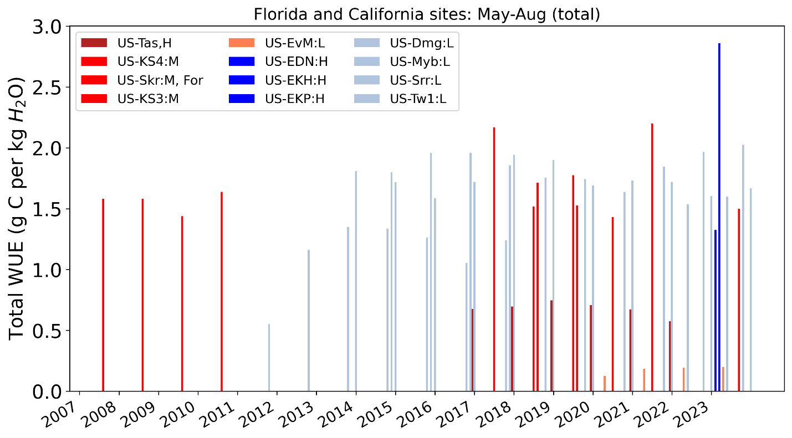
In this study we also studied the effect of WUE on salinity across different biomes. The five Florida sites are represented in varying shades of red, while the seven California sites are depicted in different shades of blue (Fig. 4). The California sites are categorized under low and medium salinity levels, whereas the Florida sites span all three salinity categories. Our analysis (Fig. 4) indicates that variations in WUE cannot be solely attributed to salinity, as regional differences also play a role.

Fig.4. WUE was calculated for sites in Florida and California during the growing season. Darker shade represents higher salinity.

